Department of ECE

Lecture Notes

EC1015 - SATELLITE COMMUNICATION

Unit I Overview of Satellite Systems, Orbits and Launching Methods
Communication Satellite:-
A communications satellite (Comsat) is an artificial satellite stationed in space for the purposes of telecommunications. Modern communications satellites use geostationary orbits, Molniya orbits or low polar Earth orbits. They are also used for mobile applications such as communications to ships and planes, for which application of other technologies, such as cable, are impractical or impossible.
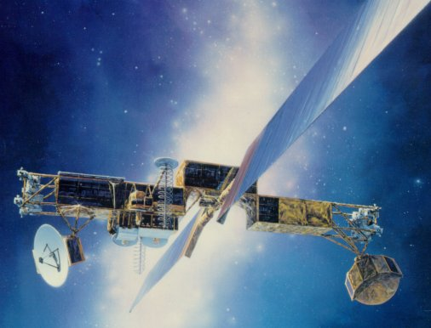

U.S. military MILSTAR communications satellite

Early Missions:-
The first satellite equipped with on-board radio-transmitters was the Soviet Sputnik 1, launched in 1957. The first American satellite to relay communications was project score in 1958, which used a tape recorder to store and forward voice messages. It was used to send a Christmas greeting to the world from President Eisenhower.
NASA launched an Echo satellite in 1960; the 100-foot aluminized PET film balloon served as a passive reflector for radio communications. Courier 1B, (built by Philco) also launched in 1960, was the world’s first active repeater satellite.
Telstar was the first active, direct relay communications satellite. It was placed in an elliptical orbit (completed once every 2 hours and 37 minutes), rotating at a 45° angle above the equator.
The first truly geostationary satellite launched in orbit was the Syncom 3, launched on August 19, 1964. It was placed in orbit at 180° east longitude, over the International Date Line. It was used that same year to relay television coverage on the 1964 Summer Olympics in Tokyo to the United States, the first television transmission sent over the Pacific Ocean.
Shortly after Syncom 3, Intelsat I, aka Early Bird, was launched on April 6, 1965 and placed in orbit at 28° west longitude. It was the first geostationary satellite for telecommunications over the Atlantic Ocean.

Geostationary Satellites:-
A satellite in a geostationary orbit appears to be in a fixed position to an earth based observer. A geostationary satellite revolves around the earth at a constant speed once per day over the equator.
The geostationary Satellite is useful for communication applications that uses ground based antennas, which must be directed toward the satellite, can operate effectively without the need for expensive equipment to track the satellite’s motion.

Low Earth Orbiting Satellites:-
A Low Earth Orbit (LEO) typically is a circular orbit about 400 kilometers above the earth’s surface and, correspondingly, a period (time to revolve around the earth) of about 90 minutes. Because of their low altitude, these satellites are only visible from within a radius of roughly 1000 kilometers from the sub-satellite point. In addition, satellites in low earth orbit change their position relative to the ground position quickly. So even for local applications, a large number of satellites are needed if the mission requires uninterrupted connectivity.
Low earth orbiting satellites are less expensive to position in space than geostationary satellites and, because of their closer proximity to the ground, require lower signal strength.
A group of satellites working in concert thus is known as a satellite constellation. Two such constellations which were intended for provision for hand held telephony, primarily to remote areas, were the Iridium and Globalstar. The Iridium system has 66 satellites.
It is also possible to offer discontinuous coverage using a low Earth orbit satellite capable of storing data received while passing over one part of Earth and transmitting it later while passing over another part. This will be the case with the CASCADE system of Canada’s cassiope communications satellite.

Low Polar Earth Orbit Satellites:-
As mentioned, geostationary satellites are constrained to operate above the equator. As a consequence, they are not always suitable for providing services at high latitudes: for at high latitudes a geostationary satellite may appear low on (or even below) the horizon, affecting connectivity and causing multipathing (interference caused by signals reflecting off the ground into the ground antenna). The first satellite of Molniya series was launched on April 23, 1965 and was used for experimental transmission of TV signal. The Molniya orbit is highly inclined, guaranteeing good elevation over selected positions during the northern portion of the orbit. (Elevation is the extent of the satellite’s position above the horizon. Thus a satellite at the horizon has zero elevation and a satellite directly overhead has elevation of 90 degrees).
Furthermore, the Molniya orbit is so designed that the satellite spends the great majority of its time over the far northern latitudes, during which its ground footprint moves only slightly. Its period is one half day, so that the satellite is available for operation over the targeted region for eight hours every second revolution. In this way a constellation of three Molniya satellites (plus in-orbit spares) can provide uninterrupted coverage.
Molniya satellites are typically used for telephony and TV services over Russia. Another application is to use them for mobile radio systems (even at lower latitudes) since cars travelling through urban areas need access to satellites at high elevation in order to secure good connectivity, e.g. in the presence of tall buildings.
Applications:-
Telephony:-
The first and historically the most important application for communication satellites is in international telephony. Fixed-point telephones relay calls to an earth station, where they are then transmitted to a geostationary satellite. An analogous path is then followed on the downlink. In contrast, mobile telephones (to and from ships and airplanes) must be directly connected to equipment to uplink the signal to the satellite, as well as being able to ensure satellite pointing in the presence of disturbances, such as waves onboard a ship.

Satellite Television and Radio:-
Television became the main market, its demand for simultaneous delivery of relatively few signals of large bandwidth to many receivers being a more precise match for the capabilities of geosynchronous comsats. Two satellite types are used for North American television and radio:
- Direct Broadcast Satellite (DBS), and
- Fixed Service Satellite (FSS).
A direct broadcast satellite is a communications satellite that transmits to small DBS satellite dishes (usually 18 to 24 inches in diameter). Direct broadcast satellites generally operate in the upper portion of the microwave K_{u} band. DBS technology is used for DTH-oriented (Direct-To-Home) satellite TV services, such as DirecTV, DISH Network.
Fixed Service Satellites use the C band, and the lower portions of the K_{u} bands. They are normally used for broadcast feeds to and from television networks and local affiliate stations (such as program feeds for network and syndicated programming, live shots, and backhauls), as well as being used for distance learning by schools and universities, business television (BTV), Videoconferencing, and general commercial telecommunications. FSS satellites are also used to distribute national cable channels to cable TV headends.
FSS satellites differ from DBS satellites:
- FSS have a lower RF power output than the DBS.
- FSS requires a much larger dish for reception (3 to 8 feet in diameter for K_{u} band, and 12 feet on up for C band).
- FSS use linear polarization for each of the transponders' RF input and output where as DBS satellites use circular polarization.
Free-to-air satellite TV channels are also usually distributed on FSS satellites in the K_{u} band.
Mobile Satellite Technologies:-
Initially available for broadcast to stationary TV receivers, by 2004 popular mobile direct broadcast applications made their appearance with that arrival of two satellite radio systems in the United States: Sirius and XM Satellite Radio Holdings. Some manufacturers have also introduced special antennas for mobile reception of DBS television. Using GPS technology as a reference, these antennas automatically re-aim to the satellite no matter where or how the vehicle (that the antenna is mounted on) is situated. Such mobile DBS antennas are also used by JetBlue Airways for DirecTV which passengers can view on-board on LCD screens mounted in the seats.

Amateur Radio:-
Amateur radio operators have access to the OSCAR satellites that have been designed specifically to carry amateur radio traffic. Most such satellites operate as spaceborne repeaters, and are generally accessed by amateurs equipped with UHF or VHF radio equipment and highly directional antennas such as Yagis or dish antennas. Due to the limitations of ground-based amateur equipment, most amateur satellites are launched into fairly low Earth orbits, and are designed to deal with only a limited number of brief contacts at any given time. Some satellites also provide data-forwarding services using the AX.25 or similar protocols.
Satellite Broadband:-
In recent years, satellite communication technology has been used as a means to connect to the Internet via broadband data connections. This can be very useful for users who are located in very remote areas, and cannot access a wireline broadband or dialup connection.

Frequency Bands for Satellite Communication:-
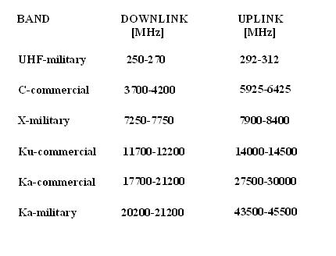

What is C Band?
C Band is the original frequency allocation for communications satellites.
C-Band uses 3.7-4.2GHz for downlink and 5.925-6.425Ghz for uplink.
The lower frequencies used by C Band perform better under adverse weather conditions than the Ku band or Ka band frequencies.

C Band Variants
Slight variations of C Band frequencies are approved for use in various parts of the world.
Band | TX Frequency | RX Frequency
Extended C Band | 5.850 - 6.425 GHz | 3.625 - 4.200 GHz
Super Extended C-Band | 5.850 - 6.725 GHz | 3.400 - 4.200 GHz
INSAT C-Band | 6.725 - 7.025 GHz | 4.500 - 4.800 GHz
Palapa C-Band | 6.425 - 6.725 GHz | 3.400 - 3.700 GHz
Russian C-Band | 5.975 - 6.475 GHz | 3.650 - 4.150 GHz
LMI C-Band | 5.7250 - 6.025 GHz | 3.700 - 4.000 GHz

C Band Dishes
C Band requires the use of a large dish, usually 6' across. C Band dishes vary between 3' and 9' across, depending upon signal strength.
Because C Band dishes are so much larger than Ku and Ka Band dishes, a C Band dish is sometimes referred to in friendly jest as a BUD (Big Ugly Dish).
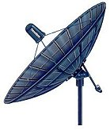

What is Ku band?
The Ku band (Kurtz-under band) is primarily used for satellite communications, particularly for editing and broadcasting satellite television. This band is split into multiple segments broken down into geographical regions, as determined by the ITU (International Telecommunication Union).
The Ku band is a portion of the electromagnetic spectrum in the microwave range of frequencies ranging from 11.7 to 12.7GHz. (downlink frequencies) and 14 to 14.5GHz (uplink frequencies).
The most common Ku band digital reception format is DVB (main profile video format) .vs the studio profile digital video format or the full-blown Digicipher II 4DTV format.
The first commercial television network to extensively utilize the Ku Band for most of its affiliate feeds was NBC, back in 1983.
The ITU Region 2 segments covering the majority of the Americas are between 11.7 and 12.2 GHz, with over 21 FSS North American Ku-band satellites currently orbiting.
Each requires a 0.8-m to 1.5-m antenna and carries twelve to twenty four transponders, of which consume 20 to 120 watts (per transponder), for clear reception.
The 12.2 to 12.7 GHz segment of the Ku Band spectrum is allocated to the broadcasting satellite service (BSS). These direct broadcast satellites typically carry 16 to 32 transponders.
Each provides 27 MHz in bandwidth, and consumes 100 to 240 watts each, accommodating receiver antennas down to 450 mm (18 inches ).
The ITU Region 1 segments of the Ku spectrum represent Africa and Europe (11.45 to 11.7 GHz band range and 12.5 to 12.75 GHz band range) is reserved for the fixed satellite service (FSS), with the uplink frequency range between 14.0 and 14.5 GHz).

Ku Band Difficulties
When frequencies higher than 10 GHz are transmitted and received used in a heavy rain fall area, a noticeable degradation occurs, due to the problems caused by and proportional to the amount of rain fall (commonly known as known as "rain fade").
This problem can be combatted, however, by deploying an appropriate link budget strategy when designing the satellite network, and allocating a higher power consumption to overcome rain fade loss. In terms of end-viewer TV reception,
it takes heavy rainfalls in excess of 100 mm per hour to have a noticeable effect.
The higher frequency spectrum of the Ku band is particularly susceptible to signal degradation- considerably more so than C band satellite frequency spectrum, though the Ku band is less vulnerable to rain fade than the Ka band frequency spectrum.
A similar phenomena, called "snow fade" (when snow accumulation significantly alters the focal point of your dish) can also occur during Winter Season.
Also, the Ku band satellites typically require considerably more power to transmit than the C band satellites. However, both Ku and Ka band satellite dishes to be smaller (varying in size from 2' to 5' in diameter.)

Ku Band Satellite Service Downlink Usage Frequency Range
The Ku band downlink uses frequencies between 11.7 and 12.7GHz.
The Ku band downlink frequencies are further subdivided according to their assigned use:
Ku Band Usage | Downlink
Fixed Satellite Service | 11.7 - 12.2GHz
Broadcast Satellite Service | 12.2 - 12.7GHz
Services that can be found on the Ku-band include educational networks, business networks, sports backhauls, tele- conferences, mobile news truck feeds, international programming, and various SCPC (Single Channel Per Carrier) transmissions of analog audio, as well as FM audio services.
If you already have a operational C-band system in place, you can retrofit it to accept Ku band frequencies.
In order to do so, you will need to obtain a Ku-band LNB as well as a C/Ku band feed-horn, plus some coax cable for your Ku-band LNB.
As for the coax cable recommended- RG-6 is optimal for low loss in the 950-1450 frequency range- what Ku-band LNB processes. However, if RG-59 is your only viable option, it'll work in a pinch.

Ku Band Dish Antenna Compatibility
Iif you have a solid dish, you should have no problem converting from C band, to Ku band.
However, with a mesh dish- if the "holes" in the mesh are greater than a quarter inch, the chances of computability are not in your favor, due to the fact that your dish won't reflect Ku-band signals properly.
Therefore, you'll want to strongly consider upgrading to either a solid dish, or a mesh dish in which the hole size under 1/4", and ideally you'll want a dish that is 1 piece (or at least very few pieces); as 4 section dish is more optimal than an 8 section dish.
The fewer the sections, the more accurate your parabola shape is and thereby the more difficult it is for your dish to become warped (the smaller the number of seams- the better). And insofar as dish mounts go, the H2H (Horizon-to-Horizon) dish mount is more desirable than a polar mount.
This is due to the fact that the Ku-band demands that the dish antenna system is well-targeted and able to closely follow the orbital arc, of which the H2H mount does quite admirably, as compared to a polar mount. Also, bear in mind that you will be adjusting both the azimuth and elevation, which can be a bit tricky occasionally.

Importance of Satellite Antenna Dish Parabola
The parabolic shape of your dish is of critical importance, as warpage causes signal degradation via mis-reflection, seriously down-grading your overall system performance. Some tape and string is all that is required to do a quick warpage check and some tape.
Anchor a piece of string, stretched as tight as possible, "north" to "south" across your dish face, edge to edge. You'll want to do the same thing again, with another piece of string, only "east" to "west" across the dish face- at 90 degree angles. Be sure that both strings are tight-
If the strings come together anywhere but the direct center, then your dish has sustained warp damage and needs to be bent back into proper parabola shape, for optimal performance. If they connect in the center of your dish, likely that your dish is not warped.
So therefore, you'll want to use either the tri-supports or quad supports , as they will greatly assist in keeping your Ku-band feed-horn highly stable, even in high winds.
When your button-hook feed moving in the wind, your Ku-band reception can can easily drop out. By putting guy-wires on the button-hook feed, you'll create the much-needed support, in the event you are not able to obtain a tri support or quad support.
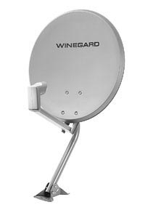

What is Ka band?
The Ka band uplink uses frequencies between 27.5GHz and 31Ghz and the downlink uses frequencies between 18.3 and 18.8Ghz and between 19.7 and 20.2Ghz.
Ka band dishes can be much smaller than C band dishes. Ka band dishes vary from 2' to 5' in diameter.
Ka band satellites typically transmit with much more power than C band satellites.
The higher frequencies of Ka band are significantly more vulnerable to signal quality problems caused by rainfall, known as rainfade
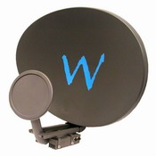

What is L band?
L band is a fequency range between 390MHz and 1.55GHz which is used for satellite communications and for terrestrial communications between satellite equipment.
The high frequencies utilized by C band, Ku band, and Ka band would suffer from high signal loss when transported over a copper coax cable such as an Intra-Facility Link.
An LNB is used to convert these higher frequency bands to L band, which can be transmitted over the IFL and processed by the IDU.
Some satellites transmit on L band, such as GPS satellites

What is S band?
S band is a frequency range from approximately 1.55 to 5.2GHz which is used for Digital Audio Radio Satellite (DARS) satellite radio systems such as Sirius Satellite Radio and XM Satellite Radio.
S band is also used by some weather and communications satellites.

Indian Satellites

Sl.No. |  | Satellite | Launch Date | Achievements
1. |  | Aryabhata | 19.04.1975 | First Indian satellite. Provided technological experience in building and operating a satellite system. Launched by Russian launch vehicle Intercosmos.
2. |  | Bhaskara-I | 07.06.1979 | First experimental remote sensing satellite. Carried TV and microwave cameras. Launched by Russian launch vehicle Intercosmos.
3. |  | Bhaskara-II | 20.11.1981 | Second experimental remote sensing satellite similar to Bhaskara-1. Provided experience in building and operating a remote sensing satellite system on an end-to-end basis. Launched by Russian launch vehicle Intercosmos.
4. |  | Ariane Passenger Payload Experiment (APPLE) | 19.06.1981 | First experimental communication satellite. Provided experience in building and operating a three-axis stabilised communication satellite. Launched by the European Ariane.
5. |  | Rohini Technology Payload (RTP) | 10.08.1979 | Intended for measuring in-flight performance of first experimental flight of SLV-3, the first Indian launch vehicle. Could not be placed in orbit.
6. |  | Rohini (RS-1) | 18.07.1980 | Used for measuring in-flight performance of second experimental launch of SLV-3.
7. |  | Rohini (RS-D1) | 31.05.1981 | Used for conducting some remote sensing technology studies using a landmark sensor payload. Launched by the first developmental launch of SLV-3
8. |  | Rohini (RS-D2) | 17.04.1983 | Identical to RS-D1. Launched by the second developmental launch of SLV-3.
9. |  | Stretched Rohini Satellite Series (SROSS-1) | 24.03.1987 | Carried payload for launch vehicle performance monitoring and for Gamma Ray astronomy. Could not be placed in orbit.
10. |  | Stretched Rohini Satellite Series (SROSS-2) | 13.07.1988 | Carried remote sensing payload of German space agency in addition to Gamma Ray astronomy payload. Could not be placed in orbit.
11. |  | Stretched Rohini Satellite Series (SROSS-C) | 20.05.1992 | Launched by third developmental flight of ASLV. Carried Gamma Ray astronomy and aeronomy payload.
12. |  | Stretched Rohini Satellite Series (SROSS-C2) | 04.05.1994 | Launched by fourth developmental flight of ASLV. Identical to SROSS-C. Still in service.
Indian National Satellite System (INSAT)
13. |  | INSAT-1A | 10.04.1982 | First operational multi-purpose communication and meteorology satellite procured from USA. Worked only for six months. Launched by US Delta launch vehicle.
14. |  | INSAT-1B | 30.08.1983 | Identical to INSAT-1A. Served for more than design life of seven years. Launched by US Space Shuttle.
15. |  | INSAT-1C | 21.07.1988 | Same as INSAT-1A. Served for only one and a half years. Launched by European Ariane launch vehicle.
16. |  | INSAT-1D | 12.06.1990 | Identical to INSAT-1A. Launched by US Delta launch vehicle. Still in service.
17. |  | INSAT-2A | 10.07.1992 | First satellite in the second-generation Indian-built INSAT-2 series. Has enhanced capability than INSAT-1 series. Launched by European Ariane launch vehicle. Still in service.
18. |  | INSAT-2B | 23.07.1993 | Second satellite in INSAT-2 series. Identical to INSAT-2A. Launched by European Ariane launch vehicle. Still in service.
19. |  | INSAT-2C | 07.12.1995 | Has additional capabilities such as mobile satellite service, business communication and television outreach beyond Indian boundaries. Launched by European launch vehicle. In service.
20. |  | INSAT-2D | 04.06.1997 | Same as INSAT-2C. Launched by European launch vehicle Ariane. Inoperable since Oct 4, 97 due to power bus anomaly.
21. |  | INSAT-2DT | January 1998 | Procured in orbit from ARABSAT
22. |  | INSAT-2E | 03.04.1999 | Multipurpose communication & meteorological satellite launched by Ariane.
23. |  | INSAT-3B | 22.03.2000 | Multipurpose communication - business communication, developmental communication and mobile communication purpose.
24. |  | GSAT-1 | 18.04.2001 | Experimental Satellite for the first developmental flight of Geo-synchronous Satellite Launch Vehicle, GSLV-D1.
25. |  | INSAT-3C | 24.01.2002 | To augment the existing INSAT capacity for communication and broadcasting, besides providing continuity of the services of INSAT-2C.
26. |  | KALPANA-1 | 12.09.2002 | METSAT was the first exclusive meteorological satellite built by ISRO named after Kalpana Chawla.
27. |  | INSAT-3A | 10.04.2003 | Multipurpose Satellite for communication and broadcasting, besides providing meteorological services along with INSAT-2E and KALPANA-1.
28. |  | GSAT-2 | 08.05.2003 | Experimental Satellite for the second developmental test flight of India's Geosynchronous Satellite Launch Vehicle, GSLV
29. |  | INSAT-3E | 28.09.2003 | Exclusive communication satellite to augment the existing INSAT System.
30. |  | EDUSAT | 20.09.2004 | India’s first exclusive educational satellite.
31. |  | HAMSAT | 05.05.2005 | Microsatellite for providing satellite based Amateur Radio Services to the national as well as the international community (HAMs).
32. |  | INSAT-4A | 22.12.2005 | The most advanced satellite for Direct-to-Home television broadcasting services.
33. |  | INSAT-4C | 10.07.2006 | State-of-the-art communication satellite - could not be placed in orbit.
34. |  | INSAT-4B | 12.03.2007 | An identical satellite to INSAT-4A further augment the INSAT capacity for Direct-To-Home (DTH) television services and other communications.
35. |  | INSAT-4CR | 02.09.2007 | Designed to provide Direct-To-home (DTH) television services, Video Picture Transmission (VPT) and Digital Satellite News Gathering (DSNG), identical to INSAT- 4C .
Indian Remote Sensing Satellite (IRS)
36. | IRS-1A |  | 17.03.1988 | First operational remote sensing satellite. Launched by a Russian Vostok.
37. | IRS-1B |  | 29.08.1991 | Same as IRS-1A. Launched by a Russian Launch vehicle, Vostok. Still in service.
38. | IRS-1E |  | 20.09.1993 | Carried remote sensing payloads. Could not be placed in orbit.
39. | IRS-P2 |  | 15.10.1994 | Carried remote sensing payload. Launched by second developmental flight of PSLV.
40. | IRS-1C |  | 28.12.1995 | Carries advanced remote sensing cameras. Launched by Russian Molniya launch vehicle. Still in service.
41. | IRS-P3 |  | 21.03.1996 | Carries remote sensing payload and an X-ray astronomy payload. Launched by third developmental flight of PSLV. Still in service.
42. | IRS-1D |  | 29.09.1997 | Same as IRS-1C. Launched by India's PSLV service. In service.
43. | IRS-P4 Oceansat |  | 26.05.1999 | Carries an Ocean Colour Monitor (OCM) and a Multi-frequency Scanning Microwave Radiometer (MSMR), Launched by India’s PSLV-C2,
44. | Technology Experiment Satellite (TES) |  | 22.10.2001 | Technology Experiment Satellite Launched by PSLV-C3 .
45. | IRS-P6 Resourcesat-1 |  | 17.10.2003 | Launched by PSLV - C5, carries three camera, names, LISS-4, LISS-3 and AwiFS
46. | CARTOSAT -1 |  | 05.05.2005 | Launched by PSLV-C6, carries two panchromatic cameras - PAN (fore) and PAN (aft) - with 2.5 meter resolution. The cam mounted with a tilt of +26 deg and -5 deg along the track to provide stereo images.
47. | CARTOSAT - 2 |  | 10.01.2007 | Launched by PSLV-C7, it is an advanced remote sensing satellite carrying a panchromatic camera capable of providing scene specific spot imageries.
48. | SRE - 1 |  | 10.01.2007 | Launched by PSLV-C7, Space capsule Recovery Experiment (SRE-1), intended to demonstrate the technology of an orbiting platform for performing experiments in microgravity conditions. SRE-1 was recovered successfully after 12 days over Bay of Bengal.
49. | CARTOSAT-2A |  | 28.04.2008 | Identical to CARTOSAT - 2, launched by PSLV-C9
50. | IMS-1 |  | 28.04.2008 | Launched by PSLV-C9 along with CARTOSAT-2A and other Eight Nanosatellites

Keplar's Laws of Planetary Motion
Keplar devised three laws which describe the motions of the planets.
Keplar's First Law
Bodies move around the sun in elliptical orbits, with the sun at one focus. The other focus is empty.
An ellipse is basically a squashed circle. All bodies orbit in an ellipse, although some are more elliptical than others.
The Earth's average distance from the sun in 150 million km. However, at perihelion¹ it is 148 million km from the sun, and at aphelion², 152 million km. THe amount which an ellipse deviates from a perfect circle can be measured by 'eccentricity'. The Earth has an orbital eccentricity of 0.017 which is relatively circlular. Pluto has a much more eccentric orbit, with an eccentricity of 0.25, with perihelion and apthelion of 4400 and 7400 million km respectively.
If you're looking for loads of fun, the easiest way to construct an ellipse is by taking two drawing pins, sticking them into a piece of paper, wrapping a loose piece of string around them, and then using moving a pencil around the loop, keeping it taught at all times. With this method the pins represent the two foci.
Keplar's First Law is significant in that most ancient astronomers believed that the planets moved in circular orbits.
Keplars Second Law
The radius vector sweeps out equal areas in equal times.
This states that the line joining the planet to the sun sweeps the same area in equal times. This means, given Keplar's First Law, that planets orbit quickest when they are nearest the sun and the radius vector is smaller, than when they are furthest from the sun.
Keplar's Third Law
The time period squared is directly proportional to the distance cubed.
This neat relationship was discovered by Keplar before Newton worked out what gravity was. Therefore, Keplar was unable to give a proof. However:
Proof:
Fudge 1: Assume the planets have circular orbits
The planets orbit experiencing a centripetal force towards the Sun:
Fc = mv²/r
Where Fc is the centripetal force, m is the planet's mass, r is the planet's distance from the Sun
This centripetal force is provided by the gravitational force of the Sun:
Fg = GMm/r²
Where Fg is the gravitational force from the Sun, G is the Universal gravitational constant and M is the mass of the Sun.
Fg = Fc
=> GMm/r² = mv²/r
Cancelling m:
GM/r² = v²/r --[1]
If the planet moves in a circular orbit, then the distance it moves in a circle is s = 2πr, and velocity in a circle is distance over time => v = 2πr/T
=> v² = 4π²r²/T²
Sub into eqn [1] and cancel r's:
GM/r² = 4π²r/T²
Multiply both sides by T²r²:
GMT² = 4π²r³
=> T² = 4π²/GM x r³
Since 4π²/GM is a constant for any central body (eg, the Sun)
=> T²∝ r³
So he was right, after all.

¹ The point in the Earth's orbit when it is closest to the sun (helion from helios meaning the sun)
² When the Earth's furthest from the sun

Orbital Elements
Figure1
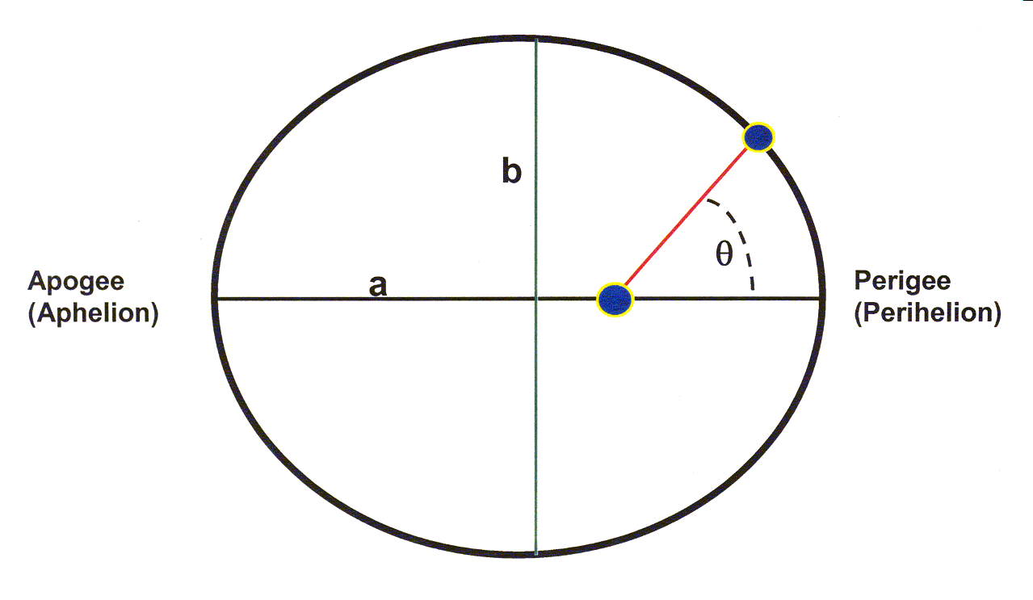
Figure2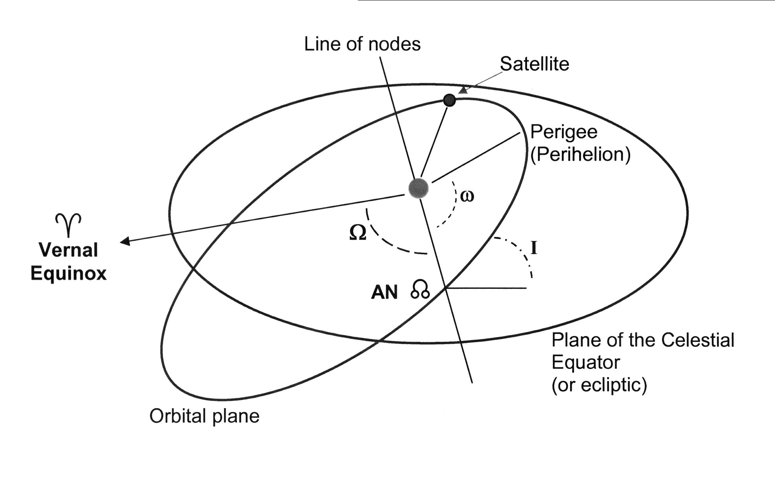

Standard Orbital Elements: (Sun orbiting object)
* Argument of Perihelion
* Eccentricity
* Inclination
* Longitude of the Ascending Node
* Semi-major axis of orbit
* Time of perihelion passage

Standard Orbital Elements: (Earth orbiting object)
(Refer to the explanations below)
* Argument of Perigee
* Eccentricity
* Inclination
* Longitude of the Ascending Node
* Period
* Semi-major axis of orbit
* Time of perigee passage
These elements are usually:
(Refer to the explanations below)
* Argument of Perigee
* Eccentricity
* Epoch
* Inclination
* Mean Anomaly
* Mean Motion
* Right Ascension of the Ascending Node
Definitions:
* Argument of Latitude (not shown): The geographic latitude of an Earth orbiting satellite at a specific time (the Epoch), expressed as an angle measured from the celestial equator northward.
* Ascending Node (AN in Figure 2): The point in a satellite's orbit where it crosses the plane of the celestial equator (or ecliptic for a sun orbiting object) going north.
* Argument of Perigee (Perihelion): (ω in Figure 2) : The angle between the ascending node and perigee (or perihelion for sun orbiting satellites), measured counter clockwise along the plane of the orbit.
* Apogee (Aphelion) (Figure 1): Point in orbit when the satellite is farthest from the Earth (sun).
* Celestial Equator: The plane of the Earth's equator projected onto the celestial sphere. The celestial equator is tilted 23.5 degrees in relation to the plane of the Earth's orbit (the ecliptic). The ecliptic and the celestial equator cross at two points, the vernal equinox and the autumnal equinox.
* Celestial Sphere: A imaginary sphere surrounding the Earth, at some arbitrary great distance, upon which the stars are considered to be fixed for the purpose of position measurement. Although it is the Earth that rotates, it appears to an observer on the Earth that the Celestial Sphere revolves around the Earth in one (sidereal) day.
* Eccentricity, e : Half of the distance between the foci of an ellipse divided by the semi-major axis. Think of it as a measure of how "out of round" an ellipse is. An eccentricity of 0 would be a circle.
* Ecliptic: The plane of the Earth's orbit around the sun. The ecliptic is the apparent path of the sun across the celestial sphere over the period of one year.
* Ecliptic Latitude: The angle between the position of an astronomical body at the time of interest and the plane of the ecliptic.
* Ecliptic Longitude: The angle of an astronomical body from the vernal equinox, measured EAST along the ecliptic.
* Epoch: The specific time at which the position of a satellite is specified.
* Geographic Longitude of the Ascending Node (not shown): The geographic longitude EAST of the Prime Meridian where the orbit of an Earth-orbiting satellite crosses the celestial equator. Do not confuse with Longitude of the Ascending Node.
* Inclination, (i in Figure 2): The angle between the plane of the orbit and the plane of the celestial equator for Earth orbiting satellites (or the plane of the ecliptic for sun orbiting satellites).
* Longitude of the Ascending Node, (Ω in Figure 2): The angle between the vernal equinox and the ascending node, measured counter-clockwise.
* Longitude of Perigee (Perihelion) The angle between the vernal equinox and perigee (or perihelion) measured in the direction of the object’s motion. It is equal to the sum of the Argument of Perigee and the Longitude of the Ascending Node (Ω + ω in figure 2).
* Mean Anomaly: (Compare with True Anomaly) The angle that a satellite would have moved since last passing perigee (or perihelion), assuming that the satellite moved at a constant speed in a orbit on a circle of the same area as the actual orbital ellipse. Equal to the True Anomaly at perigee and apogee only for elliptical orbits, or at all times for circular orbits.
* Mean Motion: The reciprocal of the Period, expressed in revolutions per day
* Meridian: An imaginary line on the surface of the Earth running from the north pole to the south pole through any given point on the Earth. Also, an imaginary line on the celestial sphere running from the North Celestial Pole to the South Celestial pole directly over any given point on the Earth. These definitions are essentially the same, one line goes under you feet, one goes over your head. The Prime Meridian is the meridian the runs through Greenwich, England (0 degrees longitude).
* Obliquity of the Ecliptic: The angle between the celestial equator and the ecliptic.
* Perigee (Perihelion) (Figure 1): The point in an orbit when the satellite is closest to the Earth (sun).
* Period: The time it takes the satellite to complete one orbit.
* Right Ascension: A measure of the angle between the vernal equinox and a given astronomical object (star, planet, or satellite), as seen from the Earth. In astronomy, Right Ascension (RA) is expressed in units of time. The RA is the time that elapses between the transit of the vernal equinox across any given meridian and the transit of the given object across the same meridian, expressed in a 24 hour format. Right Ascension can also be expressed as the angle between the vernal equinox and the object, measured EAST of the vernal equinox along the celestial equator.
* Right Ascension of the Ascending Node (Ω in Figure 2): Another term for Longitude of the Ascending Node, It is the angle of the ascending node measured EAST of the vernal equinox along the celestial equator.
* Semi-Major Axis (a in Figure 1): The half of the longer of the two axes of the orbital ellipse.
* Semi-Minor Axis (b in Figure 1): The half of the shorter of the two axes of the orbital ellipse.
* Sidereal Day: A sidereal day is the amount of time it takes the Earth to rotate once on it axis relative to the stars. A mean sidereal day is equal to 0.99727 mean solar days, or 23 hours, 56 minutes, 4.1 seconds. The mean solar day and the mean sidereal day differ due to the fact the Earth is orbiting the sun in 365.2422 mean solar days, resulting in the sun moving slightly across the celestial sphere during one solar day (24 hours)
* Time of Perigee (Perihelion) Passage: The time at which a satellite last passed perigee (or perihelion).
* True Anomaly (θ in Figure 1): The actual angle that a satellite has moved since last passing perigee (or perihelion).
* Vernal Equinox: One of two points where the ecliptic crosses the celestial equator, the other being the Autumnal Equinox. The Vernal Equinox is the point where the ecliptic crosses the celestial equator with the sun passing from south to north. Unfortunately for students of astronomy, the same term, Vernal Equinox, is used to describe both the POINT on the celestial sphere where the crossing occurs (its meaning throughout these explanations), AND the MOMENT IN TIME when the crossing occurs (the first moment of spring). Which is the intended meaning in any given sentence must be determined by the context on the statement.
Unit II Geostationary Orbit & Space Segment
Geostationary Orbit
A geostationary orbit is one in which a satellite orbits the earth at exactly the same speed as the earth turns and at the same latitude, specifically zero, the latitude of the equator. A satellite orbiting in a geostationary orbit appears to be hovering in the same spot in the sky, and is directly over the same patch of ground at all times.
A geosynchronous orbit is one in which the satellite is synchronized with the earth's rotation, but the orbit is tilted with respect to the plane of the equator. A satellite in a geosynchronous orbit will wander up and down in latitude, although it will stay over the same line of longitude. Although the terms 'geostationary' and 'geosynchronous' are sometimes used interchangeably, they are not the same technically; geostationary orbit is a subset of all possible geosynchronous orbits.
The person most widely credited with developing the concept of geostationary orbits is noted science fiction author Arthur C. Clarke (Islands in the Sky, Childhood's End, Rendezvous with Rama, and the movie 2001: a Space Odyssey). Others had earlier pointed out that bodies traveling a certain distance above the earth on the equatorial plane would remain motionless with respect to the earth's surface. But Clarke published an article in 1945's Wireless World that made the leap from the Germans' rocket research to suggest permanent manmade satellites that could serve as communication relays.
Geostationary objects in orbit must be at a certain distance above the earth; any closer and the orbit would decay, and farther out they would escape the earth's gravity altogether. This distance is 35,786 kilometers (22,236 miles) from the surface.
The first geosynchrous satellite was orbited in 1963, and the first geostationary one the following year. Since the only geostationary orbit is in a plane with the equator at 35,786 kilometers, there is only one circle around the world where these conditions obtain. This means that geostationary 'real estate' is finite. While satellites are in no danger of bumping in to one another yet, they must be spaced around the circle so that their frequencies do not interfere with the functioning of their nearest neighbors.
Geostationary Satellites
There are 2 kinds of manmade satellites in the heavens above: One kind of satellite ORBITS the earth once or twice a day, and the other kind is called a communications satellite and it is PARKED in a STATIONARY position 22,300 miles (35,900 km) above the equator of the STATIONARY earth.
A type of the orbiting satellite includes the space shuttle and the international space station which keep a low earth orbit (LEO) to avoid the deadly Van Allen radiation belts.
The most prominent satellites in medium earth orbit (MEO) are the satellites which comprise the GLOBAL POSITIONING SYSTEM or GPS as it is called.
The Global Positioning System
The global positioning system was developed by the U.S. military and then opened to civilian use. It is used today to track planes, ships, trains, cars or literally anything that moves. Anyone can buy a receiver and track their exact location by using a GPS receiver.
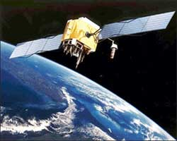  GPS satellites orbit at a height of about 12,000 miles (19,300 km) and orbit the earth once every 12 hours. |  | 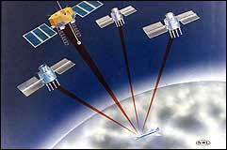  About 24 GPS satellites orbit the earth every 12 hours.
These satellites are traveling around the earth at speeds of about 7,000 mph (11,200 kph). GPS satellites are powered by solar energy. They have backup batteries onboard to keep them running in the event of a solar eclipse, when there's no solar power. Small rocket boosters on each satellite keep them flying in the correct path. The satellites have a lifetime of about 10 years until all their fuel runs out.
Geostationary Satellites
Geostationary or communications satellites are PARKED in space 22,300 miles (35,900 km) above the equator of the STATIONARY earth. Geostationary satellites are used for weather forecasting, satellite TV, satellite radio and most other types of global communications.
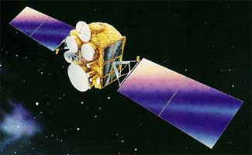
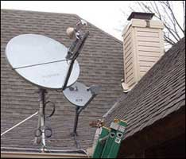
Fig A Fig B
Fig A Communications satellite in a stationary position or slot high above the earth.
Fig B Satellite dish or receiver installed on a house. These dishes point to a geostationary satellite
At exactly 22,300 miles above the equator, the force of gravity is cancelled by the centrifugal force of the rotating universe. This is the ideal spot to park a stationary satellite.
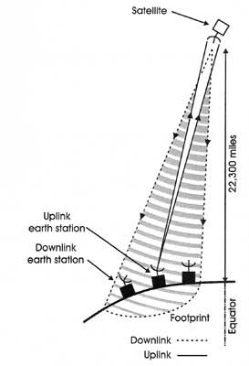 |  | 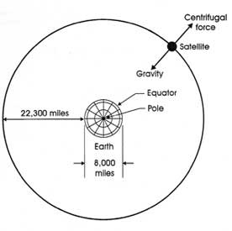  At exactly 22,000 miles (35,900 km) above the equator, the earth's force of gravity is canceled by the centrifugal force of the rotating universe. This is the ideal location to park a stationary satellite. The signal to the satellite is very, very precise and any movement of the satellite would cause a loss of the signal.
Sun outages affect a geostationary satellite
Geostationary satellites are fantastic means of communication except for one little problem called SUN OUTAGES. These sun outages happen during March and September when the sun passes the equator. Here is a quote from the book Satellite Technology:
"The elevated temperature of the sun causes it to transmit a high-level electrical noise signal to receiving systems whenever it passes behind the satellite and comes within the beams of the receiver antennas. The increase in noise is so severe that a signal outage usually results. The length and number of the outages depends on the latitude of the earth station and the diameter of the antenna. At an average latitude of 40° in the continental United States, and a 10-meter antenna, the outages occur over 6 days with a maximum duration of 8 minutes each day. With a less directional 3-meter antenna, the outages occur over 15 days, with a maximum duration of 24 minutes."(Satellite Technology, p. 13).
This is obviously very embarrassing to the heliocentric people because the sun is not supposed to move. The sun does move however, and twice a year it is over the equator.
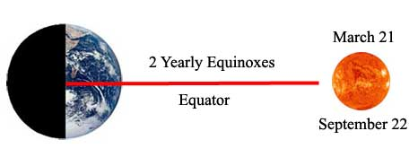
The sun moves across the equator twice a year giving us the vernal (spring) and fall (autumnal) equinoxes.
* 2 times each year the sun passes the equator as it makes it north-south spiral.
* At that time, the sun lies on the celestial equator. The word equinox refers to the fact that, on this day, the night is equal to the day: each is twelve hours long. The sun is directly above the equator, so its rays fall vertically down.
* Unfortunately the stationary satellites eclipses the sun and that causes electrical noise or interference to the broadcasting signals.
The Jesuits forgot to change the dictionary!!
Obviously the Jesuits forgot to change the definition of the word EQUINOX in the English dictionary because it still gives the true scientific definition of the word with the sun MOVING across the equator 2 times each year:
"Either of the two times during a year when the sun crosses the celestial equator and when the length of day and night are approximately equal; the vernal equinox or the autumnal equinox."(Webster's Third New International Dictionary).
PanAmSat's Description of sun outages!!
Description
PanAmSat's commercial communications satellites are geostationary, and therefore have orbits that lie near the equatorial plane. During the spring and fall equinoxes, the sun also passes close to this plane. As seen from the ground, the sun seems to pass behind the satellites once per day. During the time when both the satellite and the sun are in the ground station's field of view, the RF noise energy from the sun can overpower the signal from the satellite. It is this loss or degradation of communications traffic from the satellite that is referred to as sun fade, sun transit or sun outage (see diagram).
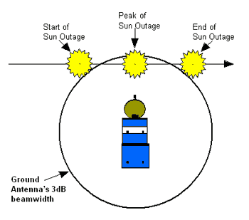
The duration of the sun outage depends on several things such as: the beam width or field of view of the receiving ground antenna, the apparent radius of the sun as seen from the Earth (about 0.25°), the RF energy given off by the sun, the transmitter power of the satellite, the gain and S/N performance of the ground station receive equipment, along with other factors. All this can affect whether a ground station will experience a complete loss of signal or only a tolerable degradation in signal quality. The exact point at which sun outage begins and ends is difficult to determine since it is a gradual transition. The gain of an antenna falls off sharply outside the 3dB beam width, but it does not immediately go to zero. Therefore, if the sun is just outside the antenna's beam width, it can still contribute noise and degrade system performance. This makes it difficult to define exactly what conditions constitute a sun outage.
How the program works
To aid with sun outage predictions, a parameter called outage angle is defined for the ground station. Outage angle is defined as the maximum separation angle (measured from the ground station antenna) between the satellite and the sun's center, that results in a sun outage. In other words, if the separation between the satellite and sun is less than the specified outage angle, then the station is said to be experiencing a sun outage. Otherwise, the station is not experiencing a sun outage (see diagram).
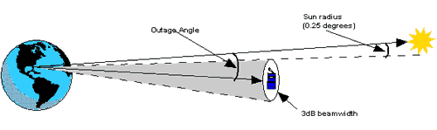
Stationary satellites need very small motors to keep them in their assigned slot!!
According to the heliocentric theory, the earth is moving at about 1,000 mph at the equator. If the geostationary satellites were moving, they would have to move at a speed of about 7,000 mph to maintain a stationary orbit above a fixed point on the earth. That is about the same speed as the GPS satellites that orbit the earth twice a day. However, GPS satellites are equipped with a rocket engine to maintain their orbit.
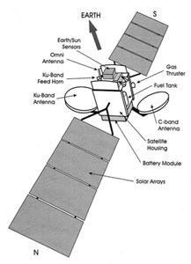  Geostationary satellite diagram.  Click on image to enlarge. |  | 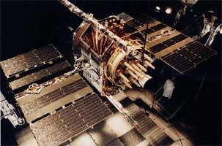  Image of a GPS satellite. Small rocket boosters on each satellite keep it flying in the correct path. The satellites have a lifetime of about 10 years until all their fuel runs out.

Spin and Three-Axis Stabilization

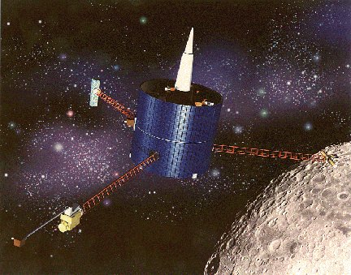
Spin and Three-Axis Stabilization
Credits - NASA
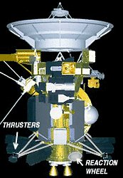
Credits - NASA
Spin stabilization and three-axis stabilization are two methods that are used to orient satellites. With spin stabilization, the entire spacecraft rotates around its own vertical axis, spinning like a top. This keeps the spacecraft's orientation in space under control. The advantage of spin stabilization is that it is a very simple way to keep the spacecraft pointed in a certain direction. The spinning spacecraft resists perturbing forces, which tend to be small in space, just like a gyroscope or a top. Designers of early satellites used spin-stabilization for their satellites, which most often have a cylinder shape and rotate at one revolution every second. A disadvantage to this type of stabilization is that the satellite cannot use large solar arrays to obtain power from the Sun. Thus, it requires large amounts of battery power. Another disadvantage of spin stabilization is that the instruments or antennas also must perform “despin” maneuvers so that antennas or optical instruments point at their desired targets. Spin stabilization was used for NASA's Pioneer 10 and 11 spacecraft, the Lunar Prospector, and the Galileo Jupiter orbiter.

With three-axis stabilization, satellites have small spinning wheels, called reaction wheels or momentum wheels, that rotate so as to keep the satellite in the desired orientation in relation to the Earth and the Sun. If satellite sensors detect that the satellite is moving away from the proper orientation, the spinning wheels speed up or slow down to return the satellite to its correct position. Some spacecraft may also use small propulsion-system thrusters to continually nudge the spacecraft back and forth to keep it within a range of allowed positions. Voyagers 1 and 2 stay in position using 3-axis stabilization. An advantage of 3-axis stabilization is that optical instruments and antennas can point at desired targets without having to perform “despin” maneuvers.

Station-keeping in LEO
Station-keeping is necessary for objects such as the International Space Station, and for satellites for which a precise knowledge of their orbital position is necessary, e.g. earth observation satellites. The International Space Station has an operational altitude above Earth between 330 and 410 km. Due to atmospheric drag, the space station is constantly losing orbital energy. In order to compensate for this loss, which would eventually lead to a reentry of the station, it is being reboosted to a higher orbit from time to time. The chosen orbital altitude is a trade-off between the delta-v needed to reboost the station and the delta-v needed to send payloads and people to the station. The upper limitation of orbit altitude is due to the constraints imposed by the Soyuz spacecraft. On 25 April 2008, the Automated Transfer Vehicle "Jules Verne" raised the orbit of the ISS for the first time, thereby proving its ability to replace (and outperform) the Soyuz at this task.

Station-keeping in GEO
Once a satellite has reached geostationary orbit, it seems natural that it should remain there. Life, of course, is not so simple because orbital perturbations cause the satellite to drift.

Inclined orbital planes
The principal correction required is to compensate for North-South drift. The geostationary plane (above the equator) is not aligned to the Earth's orbit round the Sun (ecliptic) or the Moon's orbit round the Earth, so the gravitational pull of the Sun and Moon drags satellites off the plane. Uncorrected, this would cause the inclination of the orbit to increase by approximately one degree per year. The average annual velocity change needed to correct this effect is about 50 m/s, which can represent 95% of the total station-keeping propellant budget.
Other drift pressures are also significant if uncorrected. East-West drift occurs because the equator is not perfectly circular, so satellites drift slowly towards one of two longitudinal stable points. Solar radiation pressure, caused by the transfer of momentum from the Sun’s light and infrared radiation, periodically flattens and disturbs the orientation of the orbit. Other factors, such as local irregularities in the gravitational field, also contribute less systematically to drift pressures.
Due to luni-solar perturbations and the ellipticity of the Earth equator, an object placed in a GEO without any station-keeping would not stay there. It would start building up inclination at an initial rate of about 0.85 degrees per year. After 26.5 years the object would have an inclination of 15 degrees, decreasing back to zero after another 26.5 years. Therefore, a lot of energy has to be devoted to maneuvers that compensate this tendency. This part of the GEO station-keeping is called North-South control. The ellipticity of the Earth equator is causing an East-West drift if the satellite is not placed in one of the stable (75 degrees longitude east, 105 degrees longitude west) or unstable (15 degrees longitude west, 165 degrees longitude east) equilibrium points. Nevertheless, this part of GEO station-keeping, called East-West control requires significantly less amount of fuel than North-South control. Therefore, in some cases aging satellites are only East-West controlled. This would still guarantee that the satellite is always visible to a steerable antenna.
Taking into consideration the relatively long periods of operation of modern GEO satellites (about 15 years) the delta-v expended over such a period can be substantial (about 46 m/s per year). It is therefore crucial for GEO satellites to have the most fuel-efficient propulsion system. Some modern satellites are therefore employing a high specific impulse system like plasma or ion thrusters.
TT&C Subsystem
The TT&C Subsystem contains Radio Frequency (RF) components, working in S-band, that provides the necessary functions to ensure Satellite access from the Ground Station for commanding and telemetry data transmission. The TT&C Subsystem includes:
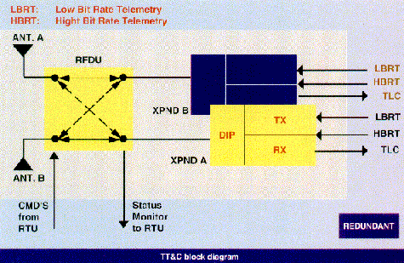
- Two S-band Transponders;
- Two S-band antennas;
- One Radio Frequency Distribution Unit (RFDU).
The Transponders are connected through the RFDU and RF coaxial cables to the two antennas that provide full spherical coverage with an overlap of at least ten degrees.
The nominal operation scenario foresees that the Receiver sections of both Transponders are always switched on.
Depending on the Satellite attitude during the Ground Station contact, only the Transmitter section of the Transponder connected to the ground-linked antenna is switched on.
One Transponder failure can be recovered through a cross coupling in the RFDU to allow the connection of the still working Transponder with both the antennas.

Unit III EARTH SEGMENT & SPACE LINK

BASIC COMPONENTS OF SATELLITE COMMUNICATION
Every communications satellite in its simplest form (whether low earth or geosynchronous) involves the transmission of information from an originating ground station to the satellite (the uplink), followed by a retransmission of the information from the satellite back to the ground (the downlink). The downlink may either be to a select number of ground stations or it may be broadcast to everyone in a large area. Hence the satellite must have a receiver and a receive antenna, a transmitter and a transmit antenna, some method for connecting the uplink to the downlink for retransmission, and prime electrical power to run all of the electronics. The exact nature of these components will differ, depending on the orbit and the system architecture, but every communications satellite must have these basic components. This is illustrated in the drawing below.
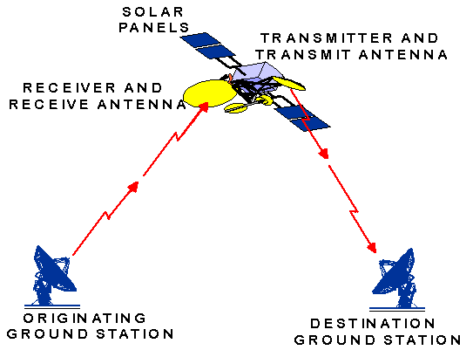

Transmitters:-
The amount of power which a satellite transmitter needs to send out depends a great deal on whether it is in low earth orbit or in geosynchronous orbit. This is a result of the fact that the geosynchronous satellite is at an altitude of 22,300 miles, while the low earth satellite is only a few hundred miles. The geosynchronous satellite is nearly 100 times as far away as the low earth satellite. We can show fairly easily that this means the higher satellite would need almost 10,000 times as much power as the low-orbiting one, if everything else were the same. (Fortunately, of course, we change some other things so that we don't need 10,000 times as much power.)
For either geosynchronous or low earth satellites, the power put out by the satellite transmitter is really puny compared to that of a terrestrial radio station. Your favorite rock station probably boasts of having many kilowatts of power. By contrast, a 200 watt transmitter would be very strong for a satellite.
Antennas:-
One of the biggest differences between a low earth satellite and a geosynchronous satellite is in their antennas. As mentioned earlier, the geosynchronous satellite would require nearly 10,000 times more transmitter power, if all other components were the same. One of the most straightforward ways to make up the difference, however, is through antenna design. Virtually all antennas in use today radiate energy preferentially in some direction.
By doubling the diameter of a reflector antenna (a big "dish") will reduce the area of the beam spot to one fourth of what it would be with a smaller reflector. We describe this in terms of the gain of the antenna. Gain simply tells us how much more power will fall on 1 square centimeter (or square meter or square mile) with this antenna than would fall on that same square centimeter (or square meter or square mile) if the transmitter power were spread uniformly (isotropically) over all directions. The larger antenna described above would have four times the gain of the smaller one. This is one of the primary ways that the geosynchronous satellite makes up for the apparently larger transmitter power which it requires.
One other big difference between the geosynchronous antenna and the low earth antenna is the difficulty of meeting the requirement that the satellite antennas always be "pointed" at the earth. For the geosynchronous satellite, of course, it is relatively easy. As seen from the earth station, the satellite never appears to move any significant distance. As seen from the satellite, the earth station never appears to move. We only need to maintain the orientation of the satellite. The low earth orbiting satellite, on the other hand, as seen from the ground is continuously moving.
Likewise, the earth station, as seen from the satellite is a moving target. As a result, both the earth station and the satellite need some sort of tracking capability which will allow its antennas to follow the target during the time that it is visible. The only alternative is to make that antenna beam so wide that the intended receiver (or transmitter) is always within it. Of course, making the beam spot larger decreases the antenna gain as the available power is spread over a larger area, which in turn increases the amount of power which the transmitter must provide.

Transponders:-
A transponder is an electronic device that produces a response when it receives a radio-frequency interrogation.


An Ontario Highway 407 toll transponder
In telecommunication, the term transponder (short-for Transmitter-responder and sometimes abbreviated to XPDR, XPNDR or TPDR) has the following meanings:
- An automatic device that receives, amplifies, and retransmits a signal on a different frequency (see also broadcast translator).
- An automatic device that transmits a predetermined message in response to a predefined received signal.
- A receiver transmitter that will generate a reply signal upon proper electronic interrogation.
A communications satellite’s channels are called transponders, because each is a separate transceiver or repeater. With digital video data compression and multiplexing, several video and audio channels may travel through a single transponder on a single wideband carrier. Original analog video only has one channel per transponder, with subcarriers for audio and automatic transmission identification service ATIS. Non-multiplexed radio stations can also travel in single channel per carrier (SCPC) mode, with multiple carriers (analog or digital) per transponder. This allows each station to transmit directly to the satellite, rather than paying for a whole transponder, or using landlines to send it to an earth station for multiplexing with other stations.

Power Generation:-
The satellite must generate all of its own power. For a communications satellite, that power usually is generated by large solar panels covered with solar cells. These convert sunlight into electricity. Since there is a practical limit to the how big a solar panel can be, there is also a practical limit to the amount of power which can generated. In addition, unfortunately, transmitters are not very good at converting input power to radiated power so that 1000 watts of power into the transmitter will probably result in only 100 or 150 watts of power being radiated.

We say that transmitters are only 10 or 15% efficient. In practice the solar cells on the most "powerful" satellites generate only a few thousand watts of electrical power. Satellites must also be prepared for those periods when the sun is not visible, usually because the earth is passing between the satellite and the sun. This requires that the satellite have batteries on board which can supply the required power for the necessary time and then recharge by the time of the next period of eclipse.

Satellite Link:-
A radio link between a transmitting Earth station and a receiving Earth station through one satellite. A satellite link comprises one uplink and one downlink.

Earth station: -

A station located either on the Earth's surface or within the major portion of the Earth's atmosphere and intended for communication:
- With one or more space stations; or
- With one or more stations of the same kind by means of one or more reflecting satellites or other objects in space.

What is uplink?
Uplink is the signal path from an earth station to a satellite.
The opposite of uplink is downlink. Downlink is the signal path from the satellite toward the earth.

Uplink Frequencies
Satellite Band | Uplink Frequency
C Band | 5.925 - 6.425 GHz
Ku Band | 14 - 14.5 GHz
Ka Band | 27.5 - 31 GHz
Uplink (U/L):-
The portion of a communications link used for the transmission of signals from an earth terminal to a satellite or to an airborne platform.

What is downlink?
Downlink is the signal path from a satellite towards the earth.
The opposite of downlink is uplink. Uplink is the signal path from an earth station towards the satellite.

Downlink Frequencies
Satellite Band | Downlink Frequency
C Band | 3.7 - 4.2 GHz
Ku Band | 11.7 - 12.7 GHz
Ka Band | 18.3 - 20.2 GHz

Downlink (D/L):-
1. A data link from a satellite or other spacecraft to a terrestrial terminal.
2. A data link from an airborne platform to a ground-based terminal.

Routers:-
A router is a device that determines the proper path for data to travel between different networks, and forwards data packets to the next device along this path.
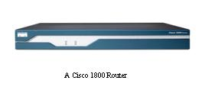

They connect networks together; a LAN to a WAN for example, to access the Internet. Some units, like the Cisco 1800 (pictured), are available in both wired and wireless models.

Routers operate in two different planes:
- Control Plane, in which the router learns the outgoing interface that is most appropriate for forwarding specific packets to specific destinations.
- Forwarding Plane, which is responsible for the actual process of sending a packet received on a logical interface to an outbound logical interface.
To understand the role of a router, understand that it does not, in a network of any real complexity, take you directly to the destination. Instead, your information will pass through a series of routers and intermediate subnets, each getting you one "hop" closer to the destination, until you reach the router that connects to the subnet that contains your final destination.
For the pure Internet Protocol (IP) forwarding function, router design tries to minimize the state information kept on individual packets. Routers do maintain state on routes, but not packets. Once a packet is forwarded, the router should retain no more than statistical information about it. It is the sending and receiving endpoint that keeps information on such things as error or missing packets.
Modems:-

A modem (modulator-demodulator) is a device or program that enables a computer to transmit data over, for example, telephone or cable lines. Computer information is stored digitally, whereas information transmitted over telephone lines is transmitted in the form of analog waves. A modem converts between these two forms.

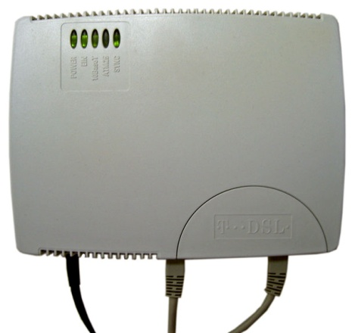

A DSL Modem
The most familiar example is a voice band modem that turns the digital ‘1s and 0s’ of personal computer into sounds that can be transmitted over telephone lines of Plain Old Telephone Systems (POTS), and once received on the other side, convert those 1s and 0s back into a form used by a USB, Serial, or Network connection.

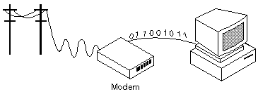

Modems are generally classified by the amount of data they can send in a given time, normally measured in bits per second, or “bps”. Fortunately, there is one standard interface for connecting external modems to computers called RS- 232. Consequently any external modem can be attached to any computer that has an RS-232 port, which almost all personal computers have. There are also modems that come as an expansion board that you can insert into a vacant expansion slot. These are sometimes called onboard or internal modems.
- Bits Per Second (bps)
- Voice/Data
- Auto-Answer
- Data compression
- Flash memory
- Fax capability
Bits per Second:-
How fast the modem can transmit and receive data. At slow rates, modems are measured in terms of baud rates. The slowest rate is 300 baud (about 25 cps). At higher speeds, modems are measured in terms of bits per second (bps). The fastest modems run at 57,600 bps, although they can achieve even higher data transfer rates by compressing the data. Obviously, the faster the transmission rate, the faster you can send and receive data. Note, however, that you cannot receive data any faster than it is being sent.
Voice/Data:-
Many modems support a switch to change between voice and data modes. In data mode, the modem acts like a regular modem. In voice mode, the modem acts like a regular telephone. Modems that support a voice/data switch have a built-in loudspeaker and microphone for voice communication.
Auto Answer:-
An auto-answer modem enables your computer to receive calls in your absence. This is only necessary if you are offering some type of computer service that people can call in to use.
Data Compression:-
Some modems perform data compression, which enables them to send data at faster rates. However, the modem at the receiving end must be able to decompress the data.
Flash Memory:-
Some modems come with flash memory rather than conventional ROM, which means that the communications protocols can be easily updated if necessary.
Fax Capability:-
Most modern modems are fax modems, which mean that they can send and receive

Unit IV SATELLITE ACCESS

ACCESS TECHNIQUES
Multiple Access Techniques:-
Multiple access techniques allow interconnection among large number of earth stations terminals simultaneously via satellite.
Alternatively with multiple access techniques any one earth station can communicate with all other earth stations using the same satellite.

- Time Division Multiple Access ( TDMA)
- Frequency Division Multiple Access (FDMA)
- Code Division Multiple Access (CDMA)
TDMA:-
In TDMA many earth stations in the satellite communications network use a single carrier for transmission via the satellite transponder on a time division basis. The earth stations transmit traffic bursts in a periodic time frame which is termed as TDMA frame.
The earth stations during their traffic transmission have the access to the entire bandwidth of the transmission.
FDMA:-
The terminology “multiple access” indicates how the radio spectrum resource is intended to be used: by enabling more than one communications signal to pass within a particular band; and the “frequency division” indicates how the sharing is accomplished: by allocating individual frequencies for each communications signal within the band.
In an FDMA scheme, the given Radio Frequency (RF) bandwidth is divided into adjacent frequency segments. Each segment is provided with bandwidth to enable an associated communications signal to pass through a transmission environment with an acceptable level of interference from communications signals in adjacent frequency segments.
CDMA:-
CDMA is a form of multiplexing and a method of multiple access to a physical medium such as a radio channel, where different users use the medium at the same time thanks to using different code sequences.
In CDMA the whole bandwidth of the transponder is used all the time and signals from the users are encoded so that information from an individual transmitter can be detected and recovered only by properly synchronized receiving station that knows the code being used.

SOME OTHER ACCESS TECHNIQUES
DAMA:-
Demand Assigned Multiple Access (DAMA) is a technology used to assign a bandwidth to clients which don't need to use it constantly. DAMA systems quickly and transparently assign communication links or circuits based on requests issued from user terminals to a network control system. When the circuit is no longer in use, the channels are immediately returned to the central pool, for reuse by others. It allows utilizing of one channel (frequency band, timeslot, etc.) by many users at different times. This technology is mainly used by small clients, as opposed to PAMA (Permanently Assigned Multiple Access). By using DAMA technology the amount of users that can use a limited pool of circuits can be greatly increased.
PAMA:-
Pre assigned Multiple Access (PAMA) is a technology used to assign a bandwidth to clients which need to use it constantly. The channel remains allocated to the client even when not in use. This technology is used by big clients as oppose to DAMA.

INFORMATION EXCHANGE
Data Exchange:-
Data Transmission:-
Computer
Router
MODEM
UP
Converter
HPA

Data is transmitted in digital form through router that determines the proper path for data to travel between the networks, and forwards data packets to the modem along this path. Modem converts this digital form of data into analog form. The frequency of this signal is then increased with the help of up converter. The power level of the signal is then amplified by the high power amplifier [HPA] and then sent to the antenna for the transmission.

Data Reception:-
LNA
Down
Converter
MODEM
Router
Computer

The data is received by the antenna and then passes through the low noise amplifier
That amplifies the weak signal received by the antenna. This amplifies signal is then passed through the down converter that decreases the frequency of the signal.
Now this analog signal is then converted to digital signal by the modem. This signal is then routed to the destination computer by the router.

Voice Exchange:-
Voice Transmission:-
Phone
Exchange
MUX
UP
Converter
HPA
Modem

Voice is transmitted through router that determines the proper path for data to travel between the networks, and forwards data packets to the modem along this path. Modem converts this digital form of data into analog form. The frequency of this signal is then increased with the help of up converter. The power level of the signal is then amplified by the high power amplifier [HPA] and then sent to the antenna for the transmission.
Voice Reception:-
LNA
Down
Converter
MODEM
Phone
Exchange

The voice signal is received by the antenna and then passes through the low noise amplifier that amplifies the weak signal received by the antenna. This amplifies signal is then passed through the down converter that decreases the frequency of the signal.
Now this analog signal is then converted to digital signal by the modem. This signal is then routed to the destination by the exchange.
Up Converter:-
The up converter contains frequency, translating circuits, which convert 70 MHz input signal to signal in the frequency, range of 5.85 GHz to 6.425 GHz. The up converter has nominal gain of 15 dB, with the nominal power being 0 dBm. The up converter contains filters for suppression of local oscillator leak and spurious products. Equalizers compensate for group delay is reduced by the filters and keep amplitude response within specifications.
High Power Amplifier (HPA):-
The high power amplifier amplifies the RF output signal from the up converter to the required power level for transmission to the satellite. Amplifiers for satellite video applications are typically sized in the range from 1watt to 3watt. Amplifiers in the 1 to 10 watt ranges available are solid state configuration. Traveling wave tube (TWT) amplifiers are available in configuration up to approximately 750 watt. For power levels above 750 Watts klystron tube amplifiers are used. The HPA usually contains BPF to reject harmonics and power sampling circuits for monitoring the output transmit power and the reflected power from the antenna. They have also the provision for increase of power from minimum to maximum value. Conventional tube fails to operate satisfactorily above 300 MHz mainly due to transmit time effect. UHF tubes try to overcome the transmit time effect by reducing the tube dimensions.
Down Converter:-
The down converter contains frequency translating circuit which converts f_{c} MHz input signal to 70 MHz signal. The down converter contains compensate for group delay introduced by the filters and keep amplitude response within specifications.
Low Noise Amplifier (LNA):-
The low noise amplifier provides high gain and low noise to establish high system G/Te. G/Te ratio is a figure of merit used to represent the quality of a satellite receiver or an earth station. Total gain G becomes the sum of antenna gain G_{a} and LNA gain G_{lna}. Te is an effective noise temperature at the input of LNA.
A transponder (also TPDR, TR, XPNDR, XPDR) is an electronic device used in wireless communications, the word itself is shorthand for transmitter-responder.
This device is primarily used as a re-transmitter due to the fact that it receives a particular signal from a particular source, then it amplifies (strengthens) the signal before sending it to a predefined location. Transponders have an abnormally large number of applications in our daily lives. Some of the most common uses are: satellite television, satellite telephony, air traffic control and in automobiles. They are also embedded in cars to open gates automatically. We shall look at some of these applications later. First of all it is important to mention that transponders are of two general varieties which are active transponders and passive transponders.
Active transponder: These devices as the name implies, continually emit radio signals which are tracked and monitored. These can also be automatic devices which strengthen the received signals and relay them to another location.
These devices are so frequently used that we often fail to recognize them. For example, how do you think lap times of NASCAR and formula one cars are monitored so accurately? Well the answer lies in the transponders which cars have embedded in them. Each car has a unique ID code which is transmitted as the car moves. A special cable loop is dug into the ground at the start-finish lines. So when the cars zoom by the finish line, their IDs are recorded along with their lap times. These times are automatically displayed on the position board along with split times, laps remaining and so on.
Another important use of active transponders is in satellite communications. Normally there are hundreds of thousands of tiny transponders embedded in one satellite. These receive an incoming signal over a range of frequencies (band), measured in hertz and megahertz and retransmit these signals on a different band simultaneously. The incoming signal originating from a point on the earth (e.g. A broadcaster), is called the uplink and the outgoing signal back to the earth is called the downlink. The logic behind using satellites for this purpose is simple - as radio signals cannot curve along the curvature of the earth, they are sent in a straight line up and received down in a straight line. This reduces time of signal delivery and increases range.
Now we come to the passive transponder which although not as active as their counterparts still play a very important role. These transponders contain information which is used to identify particular objects. For example passive transponders are sometimes embedded in our credit cards and on magnetic labels in large stores. These are paired with active transponders which amplify and transcribe the information.

Unit V DIRECT BROADCAST SATELLITE SERVICES

Direct broadcast satellite
Direct broadcast satellite (DBS) is a term used to refer to satellite television broadcasts intended for home reception, also referred to as direct-to-home signals. The expression direct-to-home or DTH was, initially, meant to distinguish the transmissions directly intended for home viewers from cable television distribution services that sometimes carried on the same satellite. The term predates DBS satellites and is often used in reference to services carried by lower power satellites which required larger dishes (1.7M diameter or greater) for reception. In Europe, the expression was common prior to the launch of ASTRA-1 in 1988 as there were two markets: the DTH market which required the larger dishes and the DBS (ASTRA) market which required smaller (0.9M dishes). As higher powered satellites like ASTRA came into operation, the acronym DBS gradually supplanted it.
The term DBS now covers both analog and digital television and radio reception, and is often extended to other services provided by modern digital television systems, including video-on-demand and interactive features. A "DBS service" usually refers to either a commercial service, or a group of free channels available from one orbital position targeting one country.

Terminology confusion
In certain regions of the world, especially in North America, DBS is used to refer to providers of subscription satellite packages, and has become applied to the entire equipment chain involved. With modern satellite providers in the United States using high power Ku-band transmissions using circular polarization, which result in small dishes, and digital compression (hence bringing in an alternative term, Digital Satellite System, itself likely connected to the proprietary encoding system used by DirecTV, Digital Satellite Service), DBS is often misused to refer to these. DBS systems are often driven by pay television providers, which drives further confusion. Additionally, in some areas it is used to refer to specific segments of the Ku-band, normally 12.2 to 12.7 GHz, as this bandwidth is often referred to as DBS or one of its synonyms. In comparison, European "Ku band" DBS systems can drop as low as 10.7 GHz.
Adding to the naming complexity, the ITU's original frequency allocation plan for Europe, the Soviet Union and Northern Africa from 1977 introduced a concept of extremely high power spot-beam broadcasting (see Ekran satellite) which they termed DBS, although only a handful of the participating countries even went as far as to launch satellites under this plan, even fewer operated anything resembling a DBS service.

Commercial DBS services
The first commercial DBS service, Sky Television plc (now BSkyB), was launched in 1989. Sky TV started as a four-channel free-to-air analogue service on the Astra 1A satellite, serving the United Kingdom and Republic of Ireland. By 1991, Sky had changed to a conditional access pay model, and launched a digital service, Sky Digital, in 1998, with analogue transmission ceasing in 2001. Since the DBS nomenclature is rarely used in the UK or Ireland, the popularity of Sky's service has caused the terms "minidish" and "digibox" to be applied to products other than Sky's hardware. BSkyB is controlled by News Corporation.
PrimeStar began transmitting an analog service to North America in 1991, and was joined by DirecTV Group's DirecTV (then owned by GM Hughes Electronics), in 1994. At the time, DirecTV's introduction was the most successful consumer electronics debut in American history. Although PrimeStar transitioned to a digital system in 1994, it was ultimately unable to compete with DirecTV, which required a smaller satellite dish and could deliver more programming. DirecTV eventually purchased PrimeStar in 1999 and migrated all PrimeStar subscribers to DirecTV equipment. In 2003, News Corporation purchased a controlling interest in DirecTV's parent company, Hughes Electronics, and renamed the company DirecTV Group.
In 1996, EchoStar's Dish Network went online in the United States and, as DirecTV's primary competitor, achieved similar success. AlphaStar also launched but soon went under. Astro was launched, using its direct broadcast satellite system.
Dominion Video Satellite Inc.'s Sky Angel also went online in the United States in 1996 with its DBS service geared toward the faith and family market. It has since grown from six to 36 TV and radio channels of family entertainment, Christian-inspirational programming and 24-hour news. Dominion, under its former corporate name Video Satellite Systems Inc., was actually the second from among the first nine companies to apply to the FCC for a high-power DBS license in 1981 and is the sole surviving DBS pioneer from that first round of forward-thinking applicants. Sky Angel, although a separate and independent DBS service, uses the satellites, transmission facilities, & receiving equipment used for Dish Network through an agreement with Echostar. Because of this, Sky Angel subscribers also have the option of subscribing to Dish Network's channels as well.
In 2003, EchoStar attempted to purchase DirecTV, but the U.S. Department of Justice denied the purchase based on anti-competitive concerns.

Free DBS services
Germany is likely the leader in free-to-air DBS, with approximately 40 analogue and 100 digital channels broadcast from the SES Astra 1 position at 19.2E. These are not marketed as a DBS service, but are received in approximately 12 million homes, as well as in any home using the German commercial DBS system, Premiere.
The United Kingdom has approximately 90 free-to-air digital channels, for which a promotional and marketing plan is being devised by the BBC and ITV, to be sold as "Freesat". It is intended to provide a multi-channel service for areas which cannot receive Freeview, and eventually replace their network of UHF repeaters in these areas
India's national broadcaster, Doordarshan, promotes a free-to-air DBS package as "DD Direct Plus", which is provided as in-fill for the country's terrestrial transmission network.
While originally launched as backhaul for their digital terrestrial television service, a large number of French channels are free-to-air on 5W, and have recently been announced as being official in-fill for the DTT network.
In North America (USA, Canada and Mexico) there are over 80 FTA digital channels available on Intelsat Americas 5, the majority of them are ethnic or religious. Other popular FTA satellites include AMC-4, AMC-6, Galaxy 10R and SatMex 5. A company called GloryStar promotes FTA religious broadcasters on IA-5 and AMC-4.
Forward Error Correction (FEC) is a type of error correction which improves on simple error detection schemes by enabling the receiver to correct errors once they are detected. This reduces the need for retransmissions.
FEC works by adding check bits to the outgoing data stream. Adding more check bits reduces the amount of available bandwidth, but also enables the receiver to correct for more errors.
Forward Error Correction is particularly well suited for satellite transmissions, where bandwidth is reasonable but latency is significant.

Forward Error Correction vs. Backward Error Correction
Forward Error Correction protocols impose a greater bandwidth overhead than backward error correction protocols, but are able to recover from errors more quickly and with significantly fewer retransmissions.

Global Positioning System
GPS is the Global Positioning System. GPS uses satellite technology to enable a terrestrial terminal to determine its position on the Earth in latitude and longitude.
GPS receivers do this by measuring the signals from three or more satellites simultaneously and determining their position using the timing of these signals.
GPS operates using trilateration. Trilateration is the process of determining the position of an unknown point by measuring the lengths of the sides of an imaginary triangle between the unknown point and two or more known points.
In the GPS system, the two known points are provided by two GPS satellites. These satellites constantly transmit an identifying signal.
The GPS receiver measures the distance to each GPS satellite by measuring the time each signal took to travel between the GPS satellite and the GPS receiver.
The formula for this is:
Distance = Velocity * Time
Velocity of the GPS signal is the speed of light, approximately 300,000 Km/s.
GPS transmissions occur on a frequency of 1575.42 and 1227.60 Mhz. Both of these frequencies are within the L Band.

GPS History
GPS was originally developed for the U.S. military, but is now provided as a public service for people all over the world by the U.S. government.
Deployment of the GPS system began on 22 February 1978 with the launch of the first Block I Navstar GPS satellite. Initial Operating Capability was declared in December of 1993 with 24 operational GPS satellites in orbit. Full Operational Capability was declared in June of 1995.
GPS was developed by the U.S. military to help soldiers locate their positions. Civilian access to the GPS system was guaranteed by President Reagan as a response to the communist Chinese shooting down of Korean Airline Flight KAL-007. President Reagan hoped that GPS technology would help to prevent such a tragedy from happening again.

GPS Architecture
The GPS system is divided into three segments:
- The Space Segment
- The Control Segment
- The User Segment

The Space Segment
GPS uses twenty-one operational satellites, with an additional three satellites in orbit as redundant backup.
GPS uses NAVSTAR satellites manufactured by Rockwell International. Each NAVSTAR satellite is approximately 5 meters wide (with solar panels extended) and weighs approximately 900Kg.
GPS satellites orbit the earth at an altitude of approximately 20,200Km.
Each GPS satellite has an orbital period of 11 hours and 58 minutes. This means that each GPS satellite orbits the Earth twice each day.
These twenty-four satellites orbit in six orbital planes, or paths. This means that four GPS satellites operate in each orbital plane.
Each of these six orbital planes is spaced sixty degrees apart. All of these orbital planes are inclined fifty-five degrees from the Equator.

The Control Segment
The Master Control Station (MCS) of the GPS system is operated at Schriever Air Force Base in Colorado Springs, Colorado. The United States Air Force maintains redundant Master Control Stations in Rockville, Maryland and Sunnyvale, California.
The Air Force also maintains monitoring stations in Colorado Springs, Hawaii, The Ascension Islands, Diego Garcia, and Kwajalein.
Communications with the space segment are conducted through ground antennas in the Ascension Islands, Diego Garcia, and Kwajalein.

The User Segment
The GPS user segment is any person with a GPS receiver.
VSAT is an abbreviation for a Very Small Aperture Terminal. It is basically a two-way satellite ground station with a less than 3 meters tall (most of them are about 0.75 m to 1.2 m tall) dish antenna stationed. The transmission rates of VSATs are usually from very low and up to 4 Mbit/s. These VSATs' primary job is accessing the satellites in the geosynchronous orbit and relaying data from terminals in earth to other terminals and hubs. They will often transmit narrowband data, such as the transactions of credit cards, polling, RFID (radio frequency identification) data, and SCADA (Supervisory Control and Data Acquisition), or broadband data, such as satellite Internet, VoIP, and videos. However, the VSAT technology is also used for various types of communications.
Equatorial Communications first used the spread spectrum technology to commercialize the VSATs, which were at the time C band (6 GHz) receive only systems. This commercialization led to over 30,000 sales of the 60 cm antenna systems in the early 1980s. Equatorial Communications sold about 10,000 more units from 1984 to 1985 by developing a C band (4 and 6 GHz) two way system with 1 m x 0.5 m dimensions.
In 1985, the current world's most used VSATs, the Ku band (12 to 14 GHz) was co-developed by Schlumberger Oilfield Research and Hughes Aerospace. It is primarily used to provide portable network connection for exploration units, particularly doing oil field drilling.

Implementations of VSAT
Currently, the largest VSAT network consists of over 12,000 sites and is administered by Spacenet and MCI for the US Postal Service (USPS). Walgreens Pharmacy, Dollar General, CVS, Riteaid, Wal-Mart, Yum! Brands (such as Taco Bell, Pizza Hut, Long John Silver's, and other fast food chains), GTEC, SGI, and Intralot also utilizes large VSAT networks. Many huge car corporations such as Ford and General Motors also utilizes the VSAT technology, such as transmitting and receiving sales figures and orders, along with announcing international communications, service bulletins, and for distance learning courses. An example of this is the "FordStar Network."
Two way satellite Internet providers also use the VSAT technology. Companies like StarBand, WildBlue, and HughesNet in the United States and SatLynx, Bluestream, and Technologie Satelitarne in Europe, and many other broadband services around the world in rural areas where high speed Internet connections cannot be provided use it too. A statistic from December 2004 showed that over a million VSATs were in place.

VSAT Configurations
Most of the current VSAT networks use a topology:
- Star topology: This topology uses a central uplink site (eg. Network operations center (NOC)), which transports the data to and from each of the VSAT terminals using satellites
- Mesh topology: In this configuration, each VSAT terminal will relay data over to another terminal through the satellite, acting as a hub, which also minimizes the need for an uplink site
- Star + Mesh topology: This combination can be achieved (as some VSAT networks do) by having multiple centralized uplink sites connected together in a multi-star topology which is in a bigger mesh topology. This topology does not cost so much in maintaining the network while also lessening the amount of data that needs to be relayed through one or more central uplink sites in the network.

VSAT's Strengths
VSAT technology has many advantages, which is the reason why it is used so widely today. One is availability. The service can basically be deployed anywhere around the world. Also, the VSAT is diverse in that it offers a completely independent wireless link from the local infrastructure, which is a good backup for potential disasters. Its deployability is also quite amazing as the VSAT services can be setup in a matter of minutes. The strength and the speed of the VSAT connection being homogenous anywhere within the boundaries is also a big plus. Not to forget, the connection is quite secure as they are private layer-2 networks over the air. The pricing is also affordable, as the networks themselves do not have to pay a lot, as the broadcast download scheme (eg. DVB-S) allows them to serve the same content to thousands of locations at once without any additional costs. Last but not least, most of the VSAT systems today use onboard acceleration of protocols (eg. TCP, HTTP), which allows them to delivery high quality connections regardless of the latency.

VSAT Drawbacks
As with everything, VSAT also has its downsides. Firstly, because the VSAT technology utilizes the satellites in geosynchronous orbit, it takes a minimum latency of about 500 milliseconds every trip around. Therefore, it is not the ideal technology to use with protocols that require a constant back and forth transmission, such as online games. Also, surprisingly, the environment can play a role in slowing down the VSATs. Although not as bad as one way TV systems like DirecTV and DISH Network, the VSAT still can have a dim signal, as it still relies on the antenna size, the transmitter's power, and the frequency band. Last but not least, although not that big of a concern, installation can be a problem as VSAT services require an outdoor antenna that has a clear view of the sky. An awkward roof, such as with skyscraper designs, can become problematic.

RADARSAT
RADARSAT is an advanced Earth observation satellite project developed by Canada to monitor environmental change and to support resource sustainablility. RADARSAT was launched on 4 Nov 1995 and is designed for a five-year lifetime.
RADARSAT uses Synthetic Aperture Radar (SAR), an active microwave sensor, allowing 24 hour data collection independent of weather conditions and illumination. The SAR sensor uses a 5.6 cm wavelength which is known as C-band, has a HH polarization (horizont transmit, horizon reveive) and has selective viewing angles that allow a wide range of terrain conditions, applications and ground coverage requirements to be accommodated.Imaging modes for RADARSAT include Fine, Standard, Wide, ScanSAR (narrow and wide), and Extended Beam (high and low incidence angles).
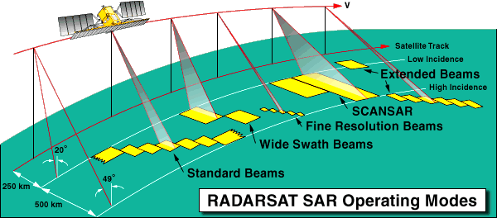

RADARSAT Processing Levels
CRISP supports the following RADARSAT processing levels.
- Signal Data (RAW) - Signal Data cannot be viewed as an image. It is an unprocessed matrix of time delays that has been repackaged to fit into standard CEOS format. Clients will require SAR processing capabilities to use Signal Data. All beam mdoes can provide Signal Data.
- Path Image (SGF) - Path Image products are recommended for individuals and organisations experienced in image processing. Path Image product is aligned parallel to the satellite's orbit path. Latitude and longitude positional information has been added to represent the first, mid, and last pixel positions of each line of data. Data from all beam modes can be processed to this product.
- Path Image Coarse (SGC) - Path Image Coarse is similar to Path Image, except that the image is block averaged by factor of 2,3,4,5 or 6. Data from all beam modes can be processed to this product.
- Single Look Complex (SLC) - Single Look Complex data retains the phase and amplitude information of the original SAR data. Single Look Complex product data is stored in slant range, and is corrected for satellite reception errors, includes latitude/longitude positional information. In addition, Single Look Complex data retains the optimum resolution available for each beam mode. This product is suitable for interferometric processing. Data from all beam modes, except ScanSAR, can be processed to this product.
- Map Image (SSG) - Map Image product is oriented with "north up" and is corrected to a user-requested map projection. The positional accuracy of Map Image processing depends on the terrain relief and the beam mode. Data from all beam modes, with the exception of ScanSAR can be processed to this product.

CRISP's RADARSAT Processing Level Availability
Beam Mode | Path Image  (SGF) | Path Image Coarse  (SGC) | Map Image  (SSG) | Signal Data  (RAW) | Single Look Complex  (SLC)
Fine
Standard
Wide
ScanSAR Narrow |  |  | Not Available |  | Not Available
ScanSAR Wide |  |  | Not Available |  | Not Available
Extended High
Extended Low
Media
Digital products are available on CD-ROM, 8mm Data Cartridge, or 9-Track CCT.
Format
All products are produced in RADARSAT CEOS format.
Film and Prints
Digital data can be produced as a film (negative or positive) or prints

RADARSAT Data Processing Time
- Near-Real TIme (NRT) - Digital products are processed within hours of reception.
- Rush - Digital products are processed within 48 hours of reception.
- Regular - Digital products are processed within 10 working days of reception.
Orbcomm
Orbcomm is a commercial venture to provide global messaging services using a constellation of 26 low-Earth orbiting satellites. The planned system is designed to handle up to 5 million messages from users utilizing small, portable terminals to transmit and receive messages directly to the satellites. The first two satellites of the constellation experienced communications problems after launch, but were recovered and placed into operational status. The nominal 26 satellite constellation will be deployed by 1997, with the potential for an additional 8 satellite plane and two more polar orbiters depending on demands for increased coverage. The vehicles will be controlled from a single control center located in Dulles, Virginia. The cost per satellite has been estimated at $1.2 million. A small forerunner vehicle, Orbcomm-X, was launched in 1991 as a feasibility demonstration. This vehicle had a different design than the operational vehicles and will not be included in the operational system.
Spacecraft
Circular disk shaped spacecraft. Circular panels hinge from each side after launch to expose solar cells. These panels articulate in 1-axis to track the sun and provide 160W. Deployed spacecraft measures 3.6 m feet from end to end with 2.3 m span across the circular disks. VHF telemetry at 57.6 kbps. On-board GPS navigation and timing system. 14 volt power system. Gravity gradient stabilization provides 5 degrees control with magnetic torquers for damping. Cold gas (nitrogen) propulsion system.
Payload
Each spacecraft carries 17 data processors and seven antennas. Designed to handle 50,000 messages per hour. Long boom is a 2.6 meter VHF/UHF gateway antenna. Receive: 2400 bps at 148 - 149.9 MHz. Transmit: 4800 bps at 137 - 138 MHz and 400.05 - 400.15 MHz. The system uses X.400 (CCITT 1988) addressing. Message size is 6 to 250 bytes typical (no maximum).
Country of Origin | United States
Customer/User | Orbcomm Inc. (subsy. of OSC)
Manufacturer(s) | Orbital Sciences
Size | Bus: 1.05 m diameter x 0.17 m thick
Orbit | Nominal constellation: 2 Polar (F 1, 2): 785 km circular / 24 Inclined: 3 planes with 8 equidistantly spaced satellites in each plane, 780 km circular, 45 deg inclination - Augmented constellation: 2 more Polar + additional 8 satellite plane
Design Life | 4 years
Launch Facts
Name | Int'l Desig. | Date | Site | Vehicle | Orbit | Mass(kg)
Notes
Orbcomm X | 1991-050C | 7/17/91 | Kourou | Ariane 4 | LEO | 22
Store and forward communication
OXP 1 | 1993-009A | 2/9/93 | ESMC | Pegasus | LEO | 15
Experimental spacecraft
Orbcomm FM1 | 1995-017A | 4/3/95 | WSMC | Pegasus | LEO | 40
Commercial communications testbed
Orbcomm FM2 | 1995-017B | 4/3/95 | WSMC | Pegasus | LEO | 40
Commercial communications testbed

